General

**Connecting to MongoDB.**

>npm install monodb

const MongoClient = require('mongodb').MongoClient;

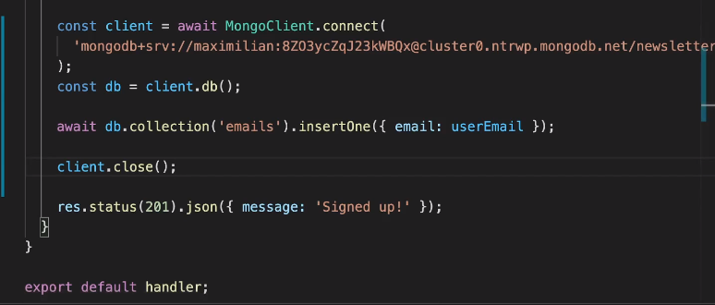

Here we can give mongoDB Key , because it is not rendered to client.

For all operations check monogdb npm documentation

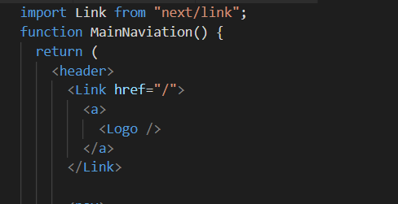

If anything other than text is passed inside the <Link> component, it should be wrapped inside <a>. This is give flexibility so that we can even make <p> tag clickable. For text it’s not necessary.

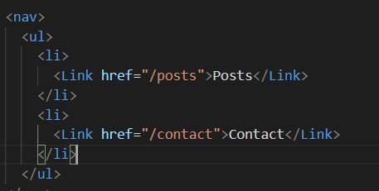

Importing CSS. If we do as below, class names will be allocated by next.js and will have some hash text.

1. Css file name : <something>.module.css
2. Import it as “classes”
3. When assigning className, give it as {classes.classname}

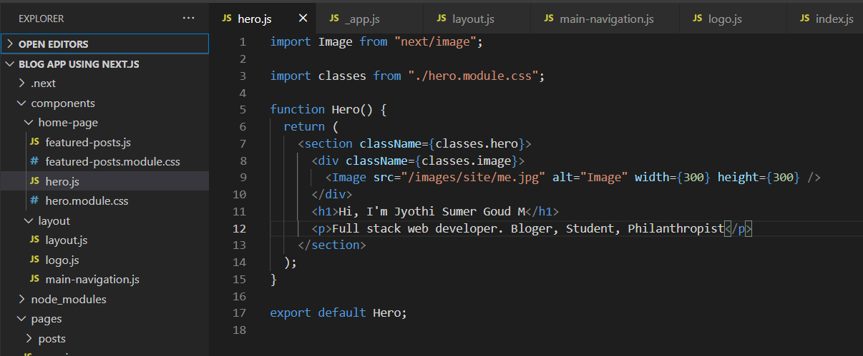 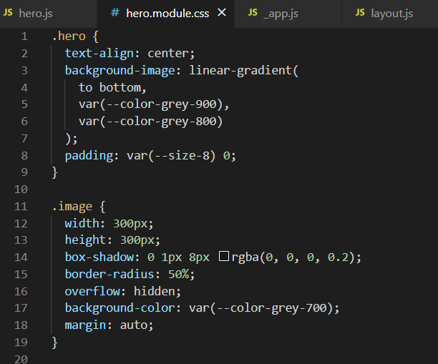

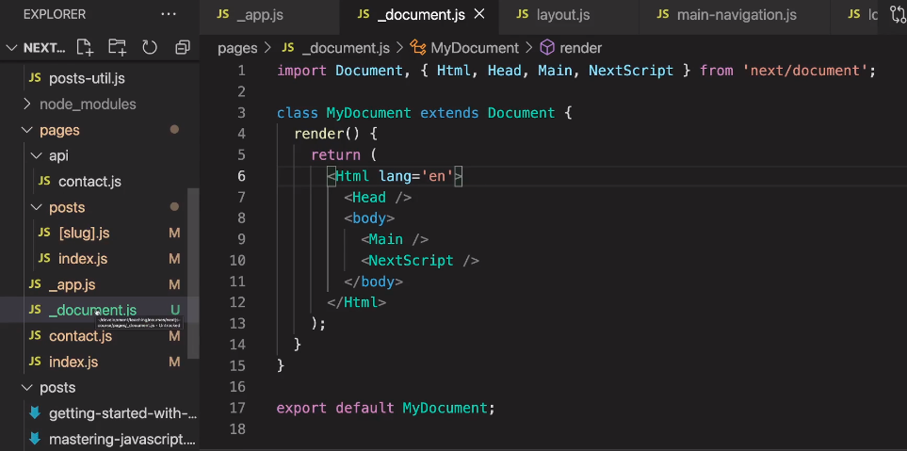

_document.js is used to add extra metadata to the file and for portals

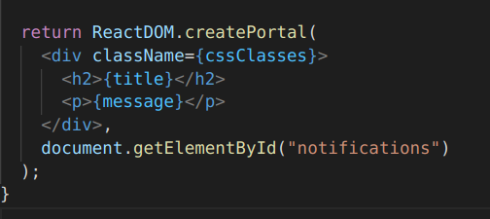

File Based routing

**Command to initialize next.js app**

npx create-next-app nextjs-blog --use-npm --example <https://github.com/vercel/next-learn-starter/tree/master/learn-starter>

* -example will take folder structure of that project

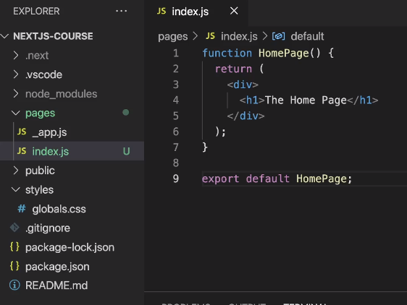

“pages” is the place where all the routing logic lies

“index.js” is the default file that runs

**File name maters**

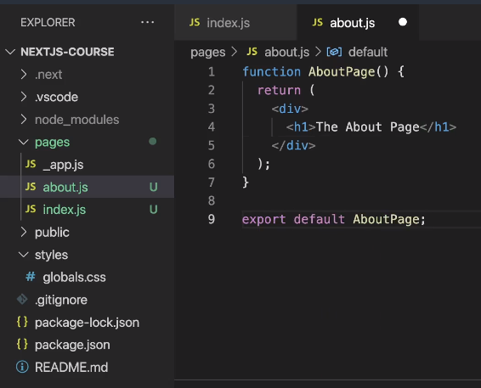

Here “about.js” file is created.

When localhost:3000/about is reached

**We can also structure in the form of folder**

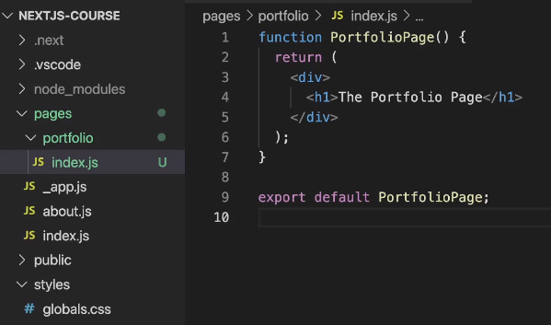

Here when we go to “localhost:3000/portfolio”, then index.js is default and that will run

Same could have been done for about.js

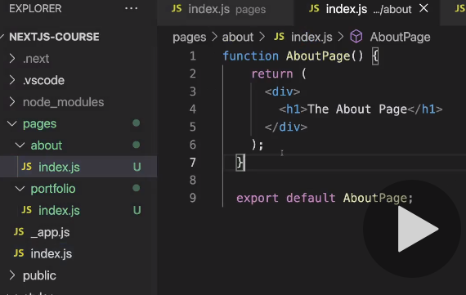

**We can have nested paths too**

Here “list.js” is created under “portfolio” folder

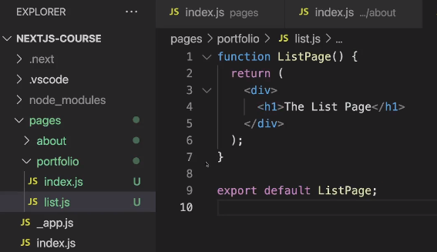

Now when we reach “lh:3000/portfolio/list” this page will be rendered.

**We can have dynamic routing.**

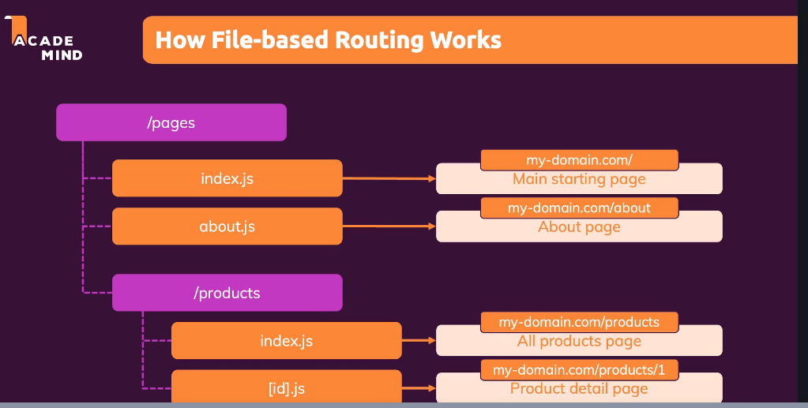

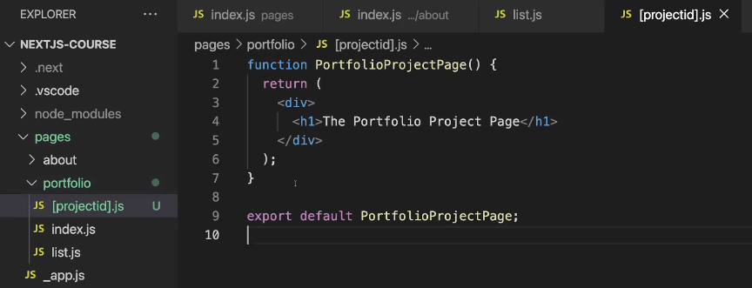

**We have to place the file name inside []**

When we reach out to “lh:3000/portfolio/<anything>” this page will run

**How to get that “anything from the URL”**

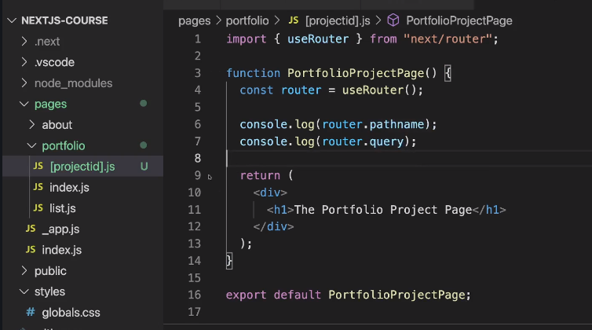 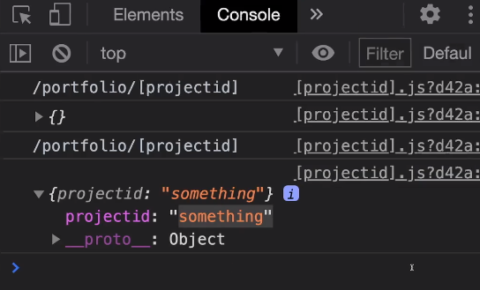

We can use “useRouter” hook that next.js provides

Now “router.query.projectid” will give the url parameter.

**Nested Dynamic Routes**

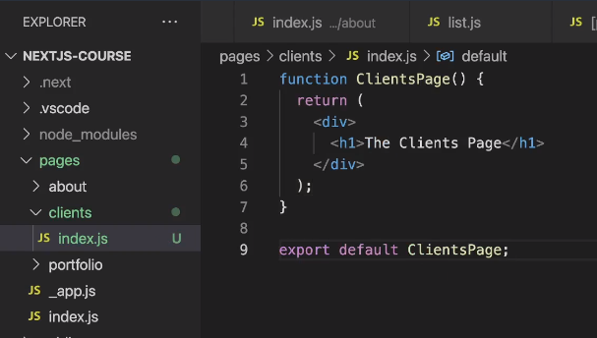

Here we have multiple children.

Inside “clients” folder we have [id] and inside that we have [clientproject].js

This will run for “lh:300/clients/<id>/<anything>

If we run “lh:300/clients/<id>”, then index.js inside [id] folder will run

This “index.js” file runs when “lh:30/clients” is requested.

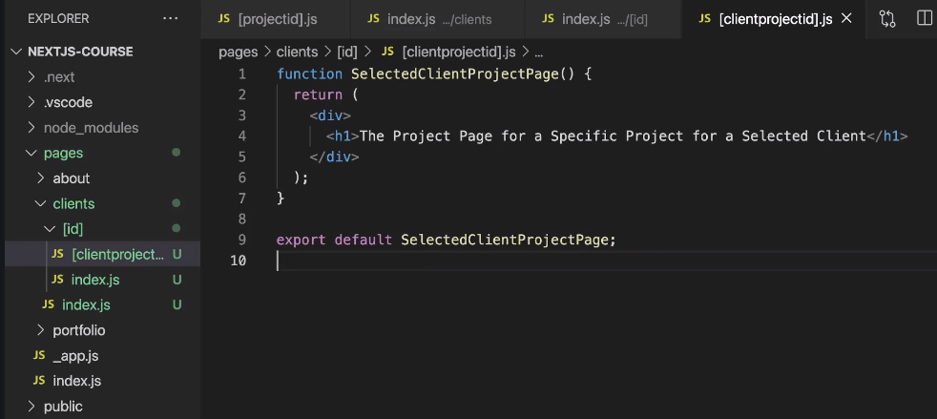

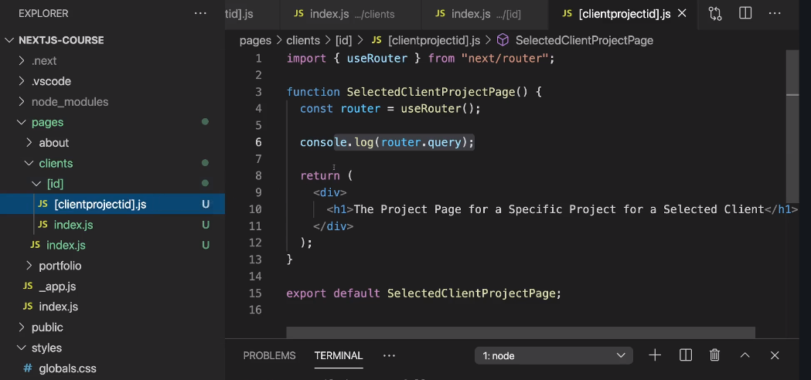

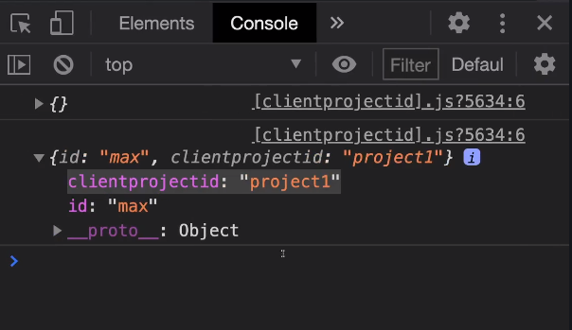

**Catch All Routes ( use … in the file name )**

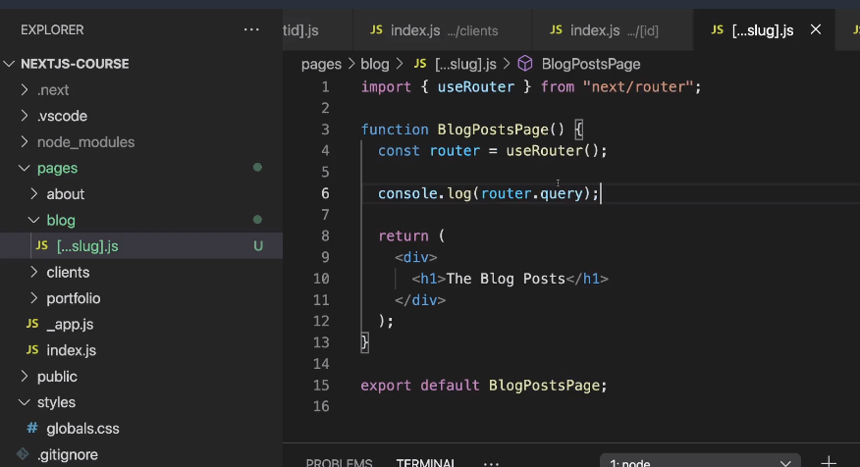

For “lh;30/blog/2012/12”

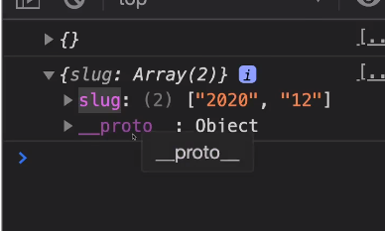

Here we can give any number of params after “blog” in the url. It will work and in router.query it will show those in an array

**Navigating via “Link”**

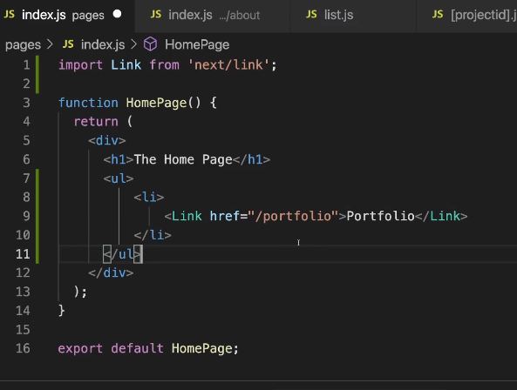



On clicking this link, it will take us to “lh:30/portfolio”

**We can give some props to Link**

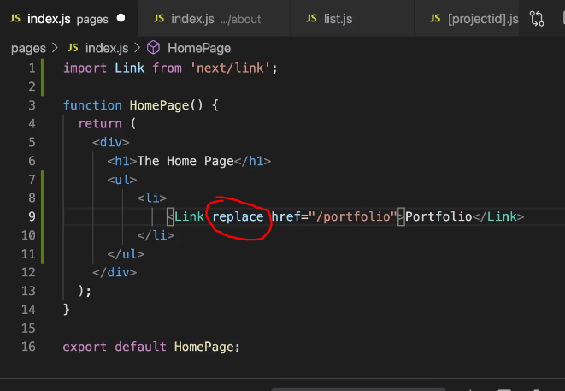

When we give “replace” as props, then page will be replace and **we cannot go back.**

**Other props for link**

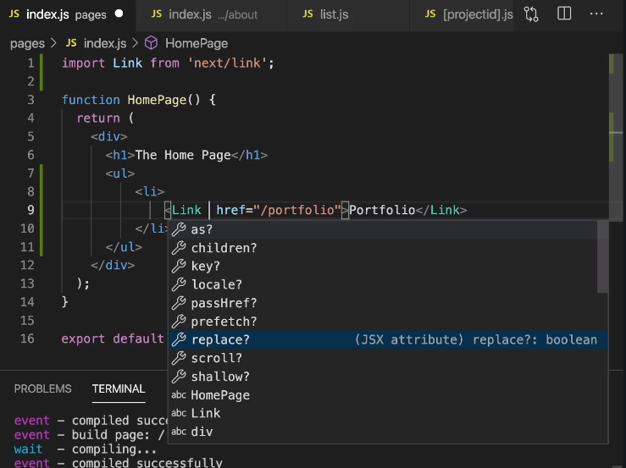

**Going to dynamic routes**

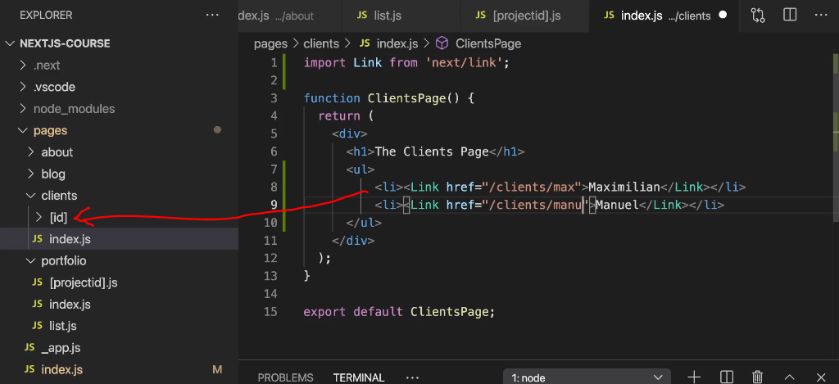

**To create Links dynamically**

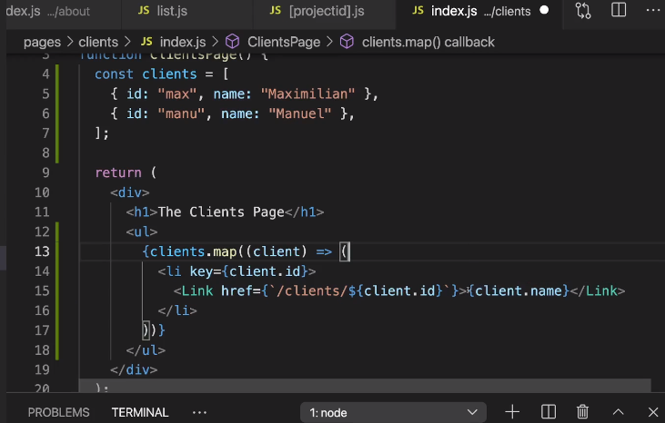



Here Links are generated logically. Not hardcoded.

**Other ways to dynamically create links**

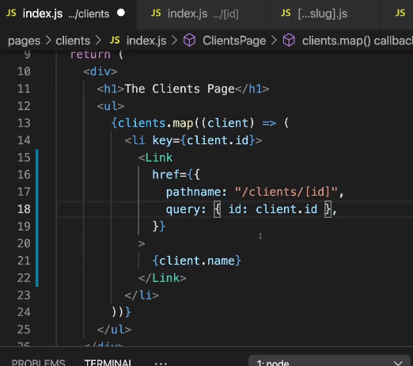

**Going to link programtically ( router.push( url to go ) );**

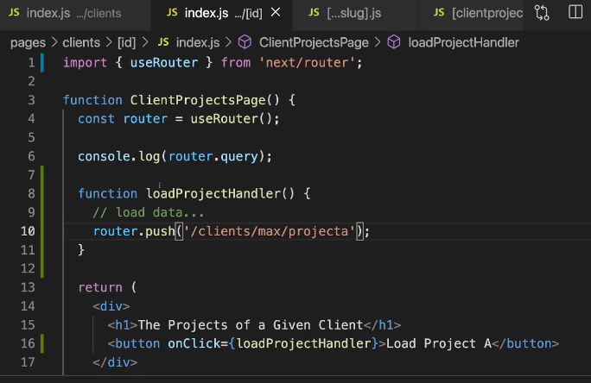

onClick should be used to do something. Inside the we will use

router.push(‘<url to go’);

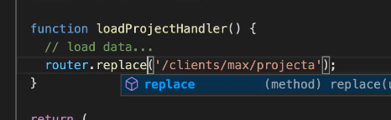

“replace” can also be used.

Other way

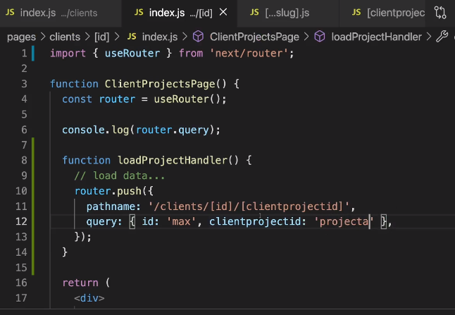

**Page not found**

File name should be “404.js”. And it should be under “pages” directly



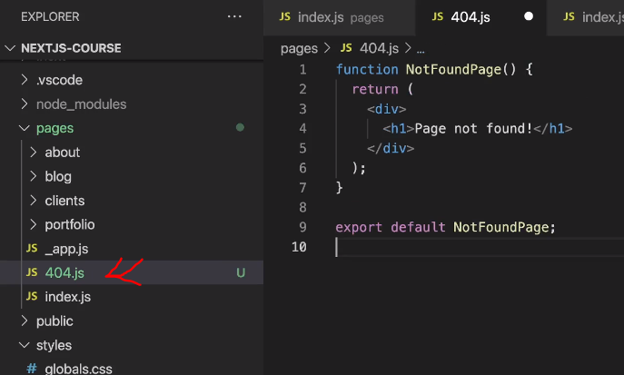

Page re-rendering and data fetching

When a page loads, with just react app, source code will not have any details resulting in poor SEO. When using Next.js we can pre render a page. So when page loads source code contains some details

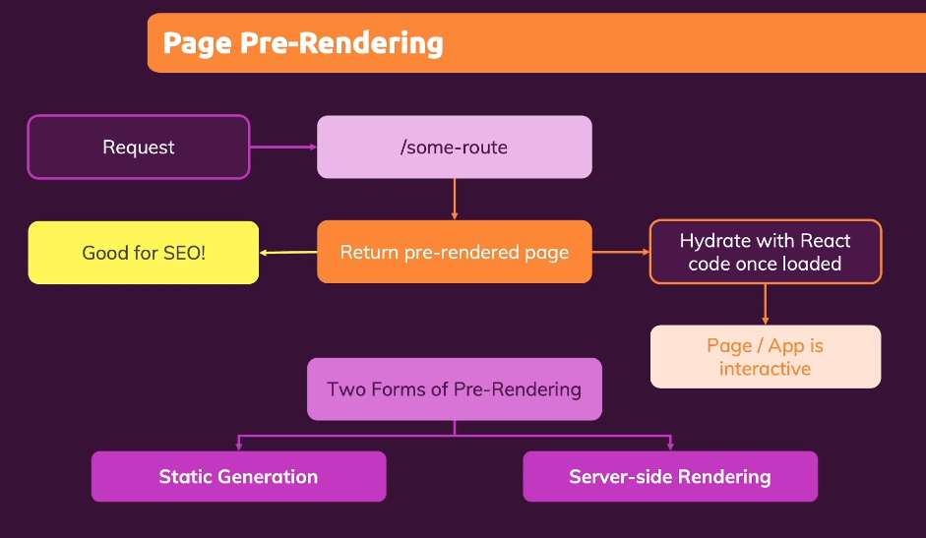

While having pre rendered page, we can also have react features.

Static Generation: Pages are created with some data while doing a build.

Server-side Rendering: Pages are created with data when request is made.

**Static Generation with "getStaticProps”** (name matters)

Whatever code that is written inside this will only be executed by backend. Data will not be sent to client side. So we can also write security keys or DB keys inside this method. “window” object will not be available inside this.



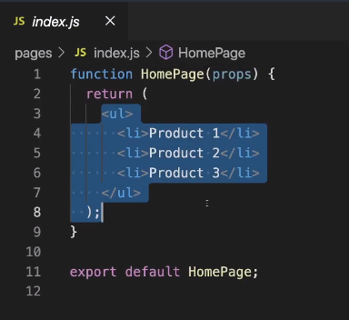 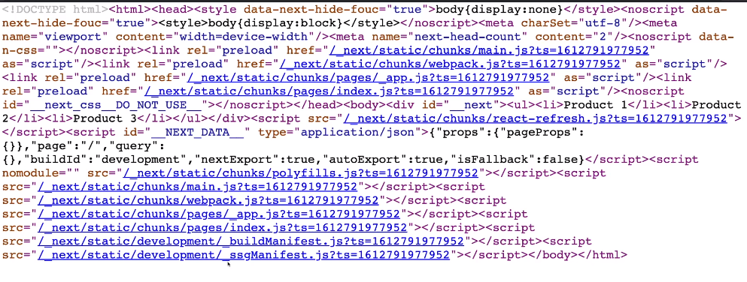

Next.js pre-renders by default.

See here since code is hard coded, next.js pre-renders content.

Using getStaticProps

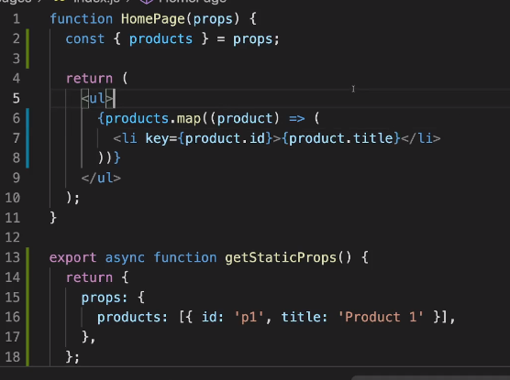

Here in getStaticProps() we are using fs module, which is available only in Node environment and not in client evn. Here we are fetching the data from /data/dummy-backend.json path and sending that to HomePage component as props.

export async getStaticProps() {

return {

//whatever is returned here will be sent as props

}

}

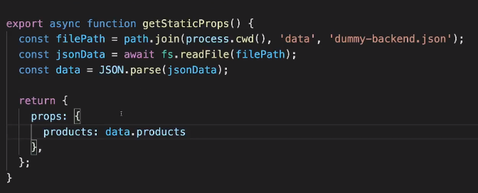 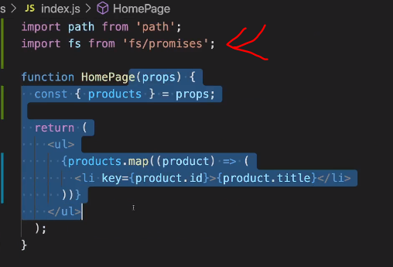

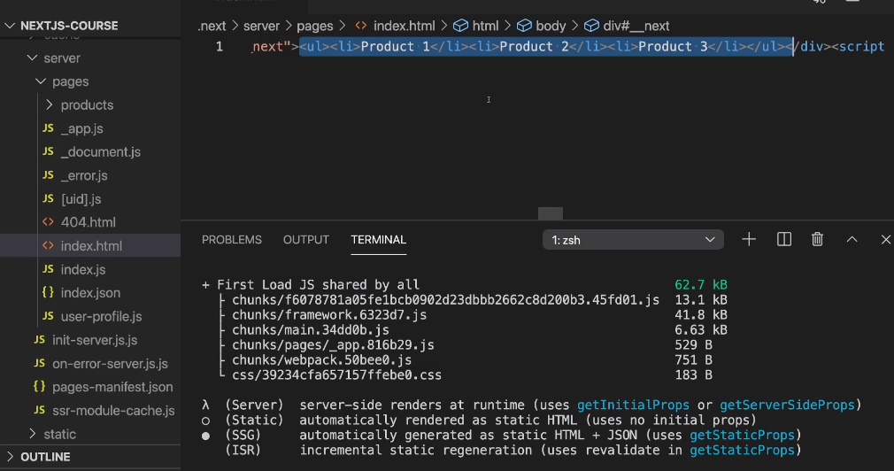

Once build is done. We can see page generated by next.js contains that details already.

npm run build 🡪 to do a build

npm start 🡪 to start production ready app

npm run dev 🡪 to start in dev mode

**Incremental Static Generation (ISR)**

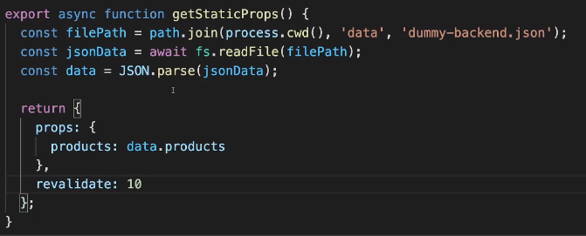

“revalidate” is the time in seconds after which the page is re-rendered again. We have to send a request for that page to rebuild again.

In dev mode, it will be build after every request, but in production it will after that X seconds.

Before 10 seconds, same page will be rendered. But after 10 secs, when new request is made new page is built and that page sent back to client. (In production only)

Couple of other parameters that we can pass as props to the components are

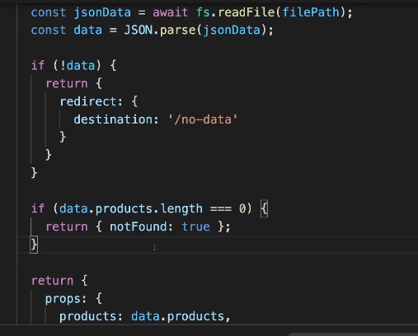

Here if data is not fetched, then we are returning

Redirect: { destination: ‘/no-data’ }

This will redirect to that page when data is not available.

If data is empty we can return a 404 page

“notFound” should be returned as “true”. Then 404 page will be shown instead of component.

“redirect” and “noFound” are 2 important return parameters

**Working with dynamic parameters**

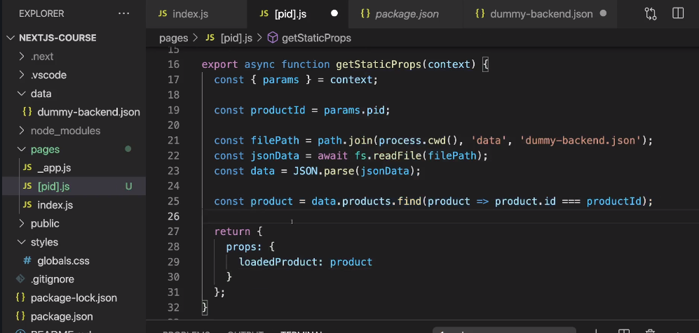

The above error is because, when getStaticProps is mentioned in a file, it makes sure that the page is re-rendered. But since it is a dynamic path, next.js doesn’t know how many pages it should render.

I here if we want to pre-render the page with a particular param then use “context” parameter provided inside getStaticProps()

“params” and “context” are names provided by next.js, they should not be changed.

Depending upon the value we can pre fetch the values and pre-render the page..

We get below error, for the left side code.

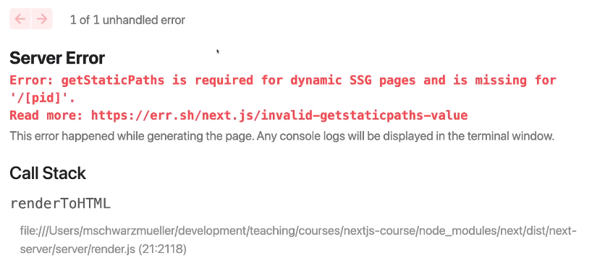

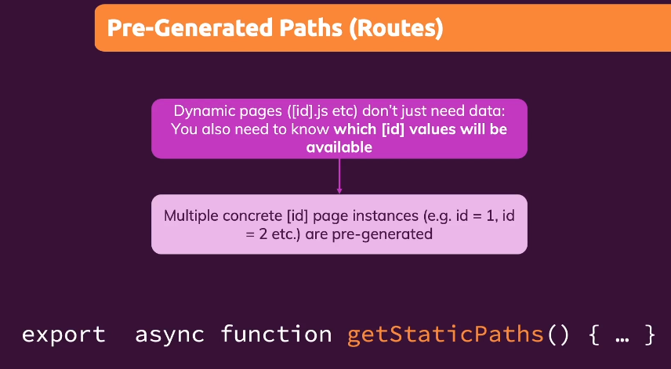 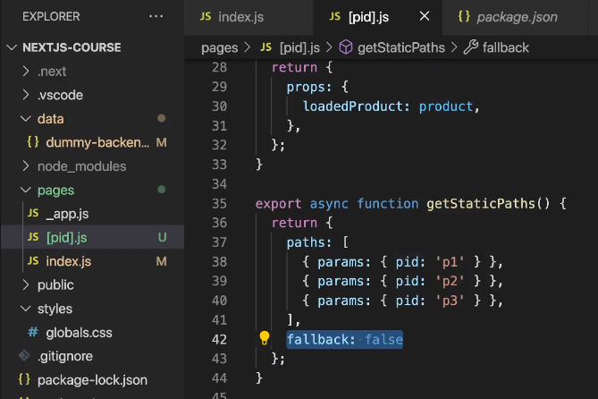

Here we are pre-defining the paths.

Pages with params: p1,p2,p3 will be pre-generated during build time.

fallback should be set to false.

After building these pages are built.

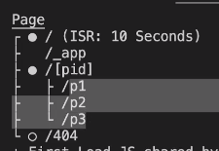

**“fallback” importance**

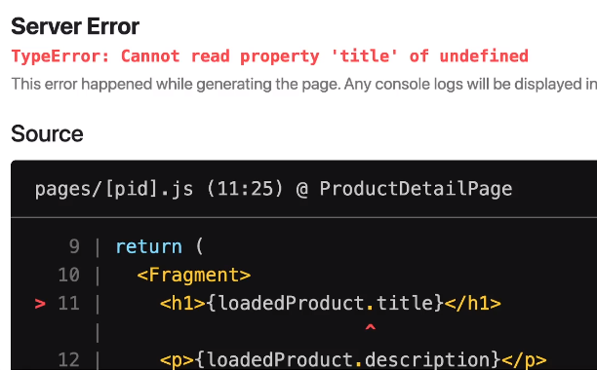

When fallBack is given as true, then we are telling next.js that there are other possible values that we can give to [pid]. Therefore we can render infinite number of pages.

This will work only if we are going to that page via link. If we directly go to that page by giving in URL, it will throw an error.

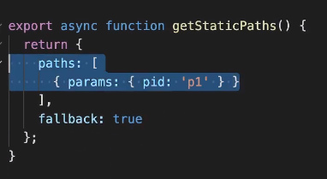

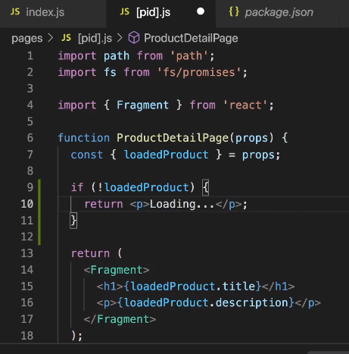

*********************IMPORTANT************************

Adding lines 9 to 11 will resolve the above issue.

When pages are loaded directly by giving path in the URL, then it takes some time to get the details, till then Loading… will be shown. After that props will have the details and page will be shown

**Alternative Way**

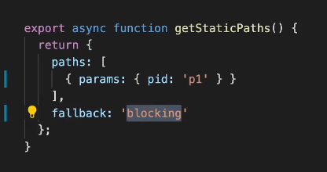 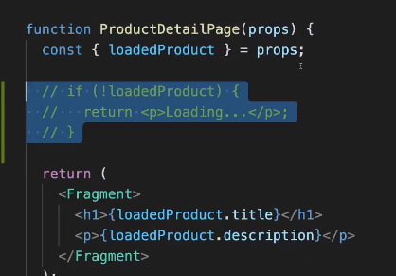

By giving “fallaback” to “blocking”, we can remove that check. Now we will only show that page when the page is completely loaded. i.e. it will be rendered on server and sent back here.

This will take some time(more than previous method).

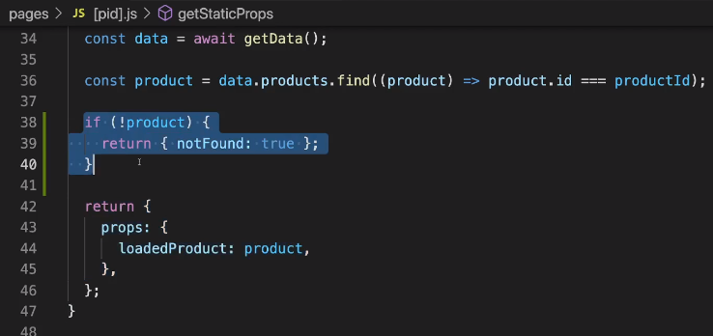

**NOTE:**

1. React hooks will not work inside “getServerSideProps” and “getStaticProps” and “getStaticPages” methods.

2. We cannot combine “getServerSideProps” and “getStaticProps”

3. We can combine client side data fetching with either “getServerSideProps” or “getStaticProps”

If we enter an url “http://lh3000/p4” then we return parameter “notFound: true”

So that if data is not there it will show 404 error page.

**\*\*\*\*\*\*\*\*\*\*\*\*\*\*\*\*\*\*\*\*\*\*\*\*\*\*\***

**Server Side Rendering**

**\*\*\*\*\*\*\*\*\*\*\*\*\*\*\*\*\*\*\*\*\*\*\*\*\*\*\***

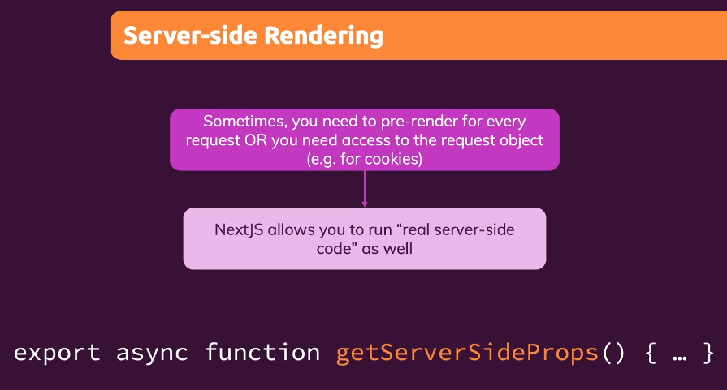 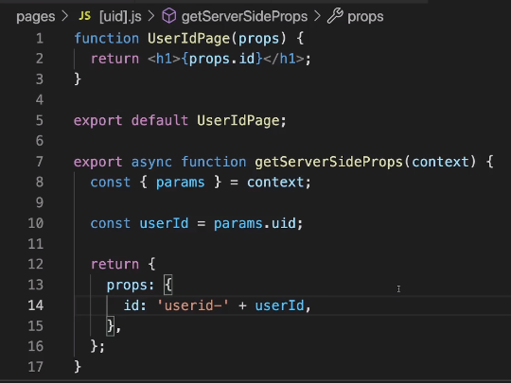

return values will be same as “getStaticProps”, except redirect will not be accepted.

The page will be rendered only once request is made.

“context” will contain “req” and “res” objects apart from params.

**Client side data fetching**

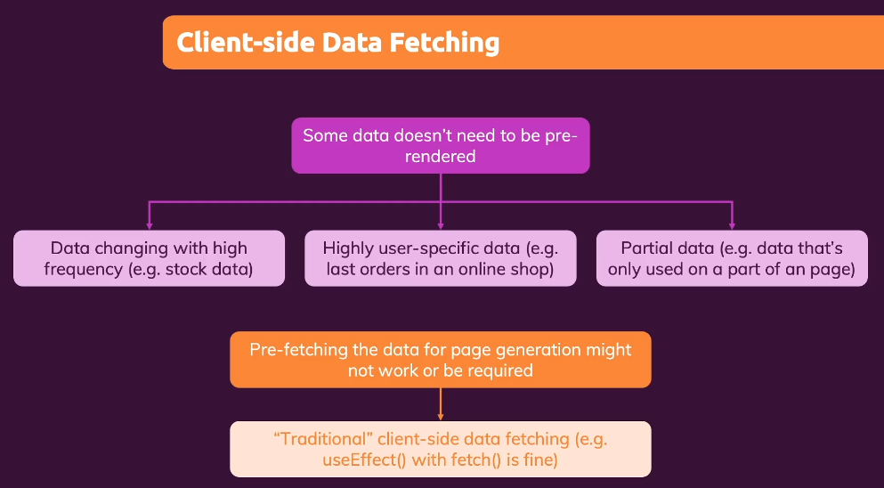

This is just like “fetch”, but contains lot of other features. It is like “Axios”.

This is normal data fetching. Just like in react, we use useEffect hook and use fetch to get some data and useState to set state and update the component.

**“useSWR” hook**

>npm install swr

Optimizing next.js app

**“Head” in next.js**

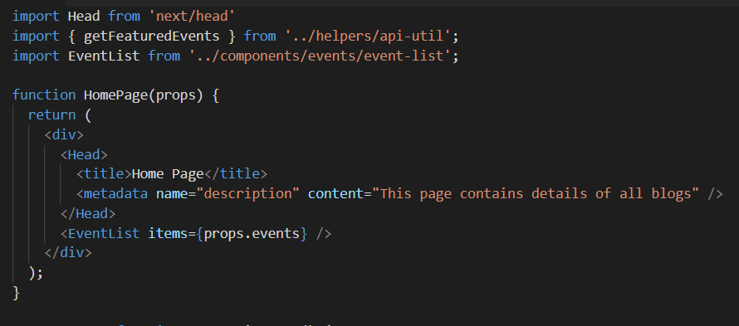

To set a nav bar in all pages use _app.js file. “Component” and “pageProps” are to be used as is.

We can also add <Head> in this file and this will be set across all pages. If content in <Head> conflicts from content _app.js to page file then latest one will be considered( e.g: containing 2 <title> tags)

Import Head from next/head

Whatever is given inside <Head> will be set to <head> tag in html page

We can set “title” which will set the title on the tab in chrome. All we can set in html page can be set here as well.

In “Head”, H should be capital

This Head can be set in any page, when that page is loaded this Head will be added.

We can also dynamically generate content in <Head> as we have access to props

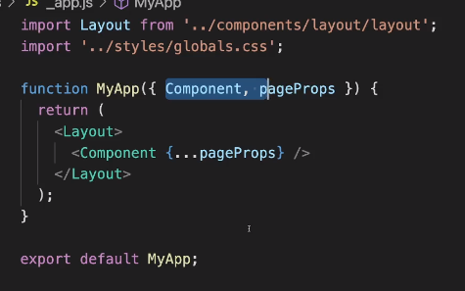 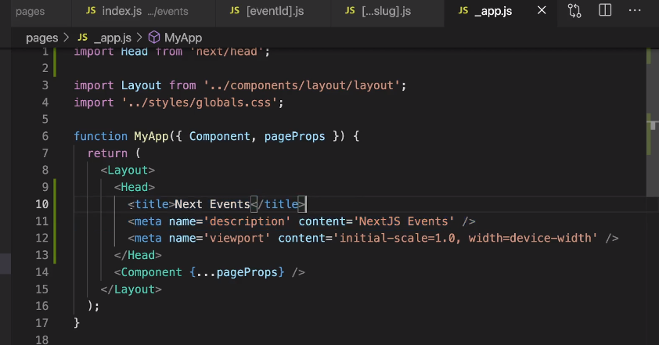

**_document.js file**

This _document.js file like _app.js but is separated with other components. “Head” that is imported from next/document is different from “Head” imported from next/head.

Here we can see whatever is given in <Html> is added to <html> tag in source code.

<div> that we added under <body> in _document.js file is added to <body> tag in source code. This #id can used to create portlets and popups



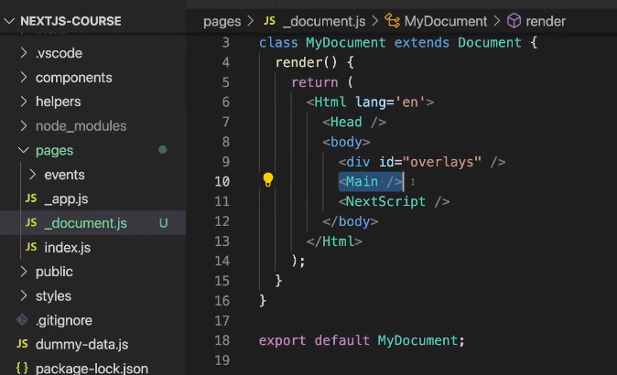 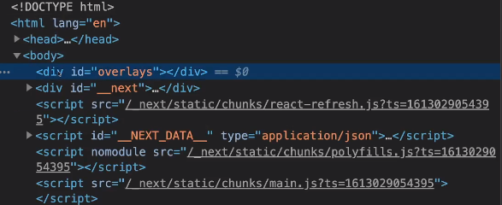

**Images**

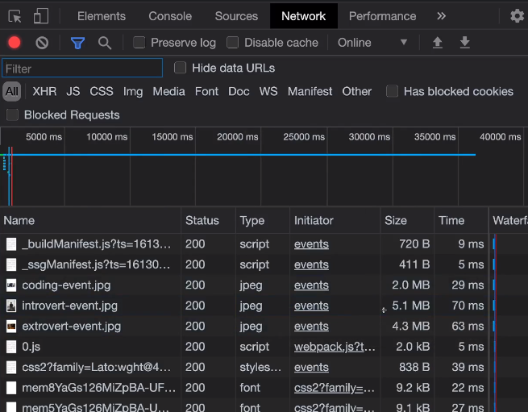

From the left image we can see that images are loaded as is. Therefore image type is .jpeg and size is in MBs

If we change the <img> tag to <Image> tag imported from “next/image” then we can see that image type is changed to “webp” and size is also reduced to KBs.

We need to give “width” and “height” props to the <Image” component. This the size of the image to be loaded in screen, not the original size of the image.

Other feature we get is “lazy load”. Request is made to get the image only when that image should be shown in the screen. i.e when an image in the bottom and will not be shown when screen is loaded, then it will not fetch that image. But when we scroll down to that part of the page, request is made to get that image.

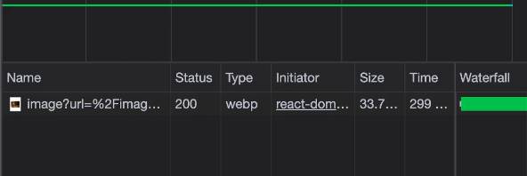

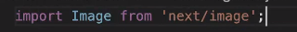

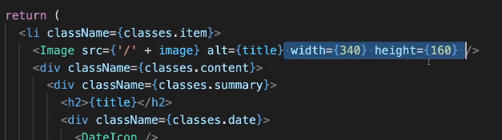 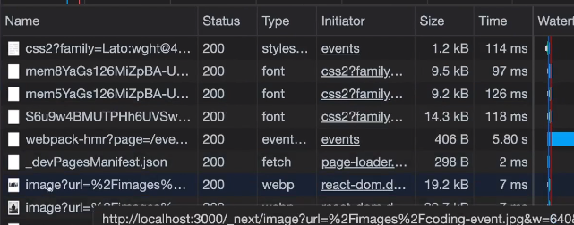

APIs in next.js app

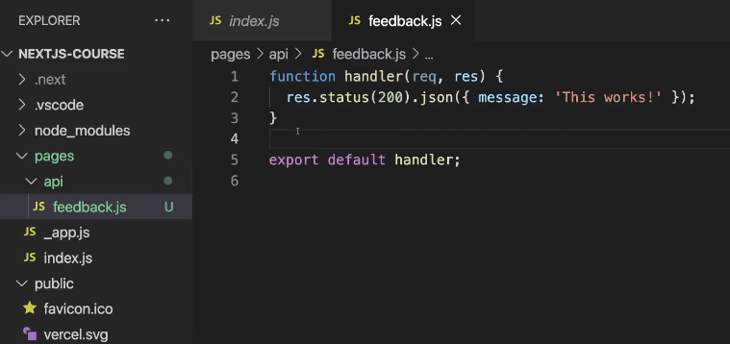

1. To create APIs, create “api” folder inside “pages”. It should be named as “api” only.

2. Code that we write inside this will be executed in Node.js environment. Just like “getStaticProps” method.

3. function name can be anything, but typically “handler” is given. And code should be similar to how we write in Express.

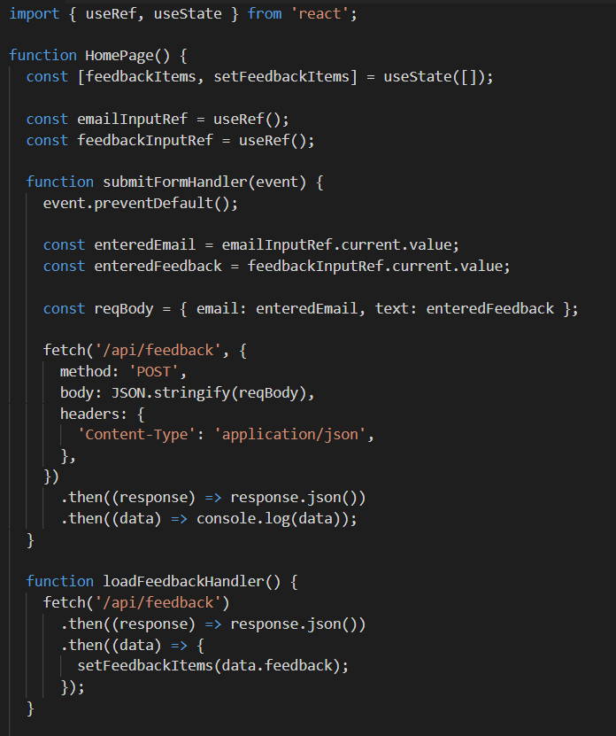 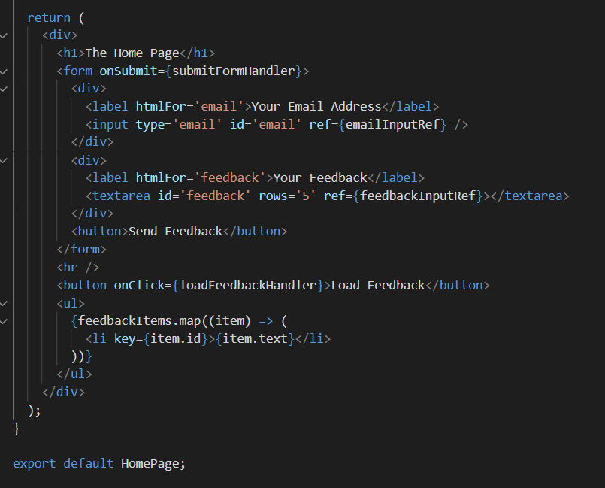

Left and blow one are index.js file, where we are posting data from the form and getting data from the file.

We use fetch to hit the APIs that we have created in “api” folder. One is post and other is get request.

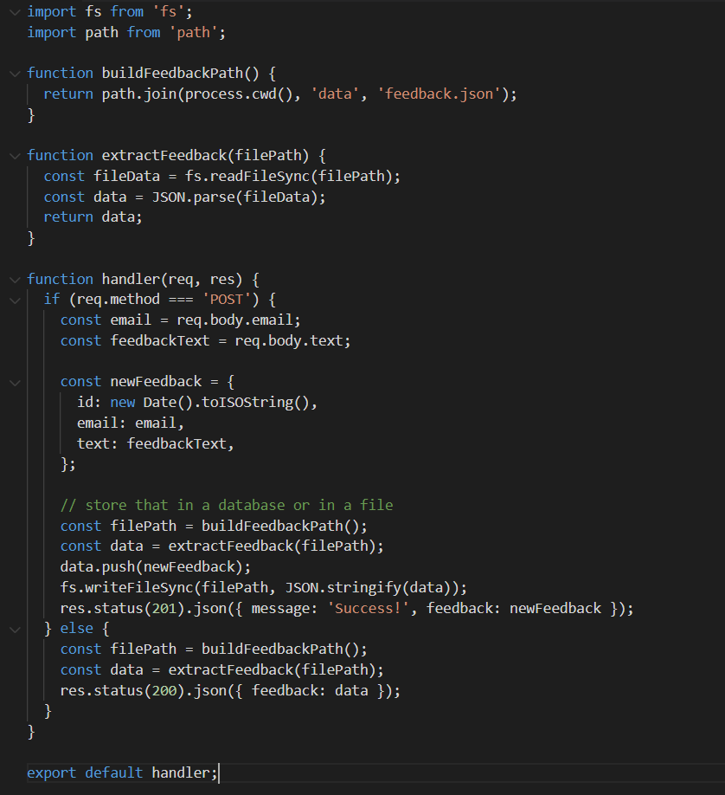

The function that we have exported will be called for any api request that go to “/api/feedback”, which is the file path actually.

We have to segregate the requests using req.method.

**Using API routes inside “getStaticProps()” method**

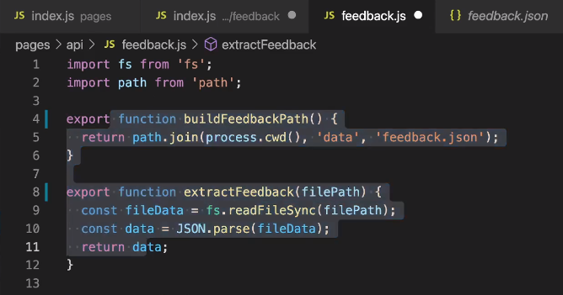

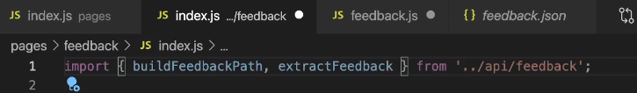 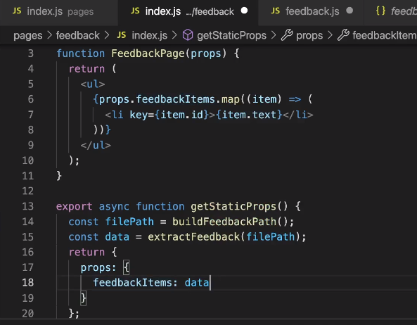

We have exported the helper functions from “api/feedback.js” and we use them by importing them

We have imported these functions in index.js. These functions will not be rendered to client side as they are used only in “getStaticProps()” method. So it’s safe to write server side keys.

Here we are getting the props via API request and sending them as props to the react method.

**Dynamic API routes**

Inside “api” folder also we can create files with [someid].js as file name. This is called when “api/<anything>” is called. We can get the query param using “req.query.someid” and do our logic.

If “api/feedback” is called then the handler inside “feedback.js” will called. “SPECIFIC to GENERIC” is the order.

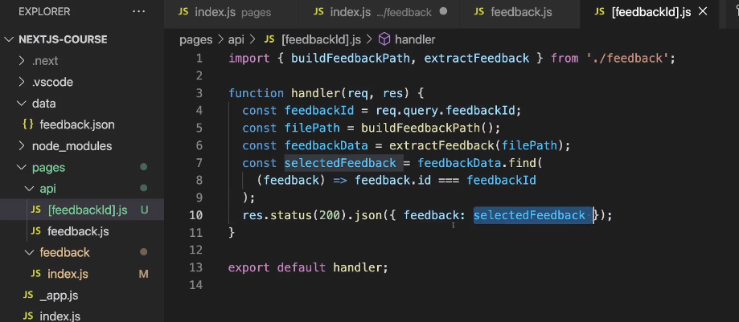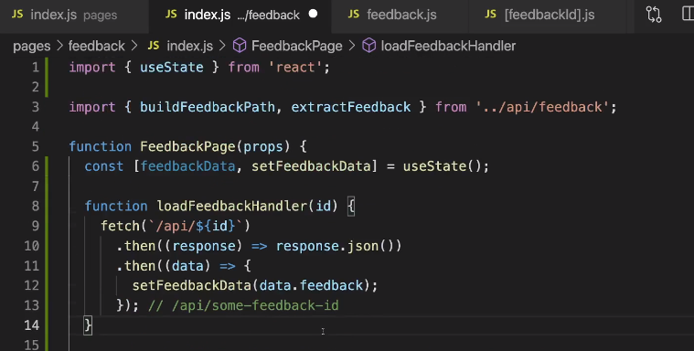

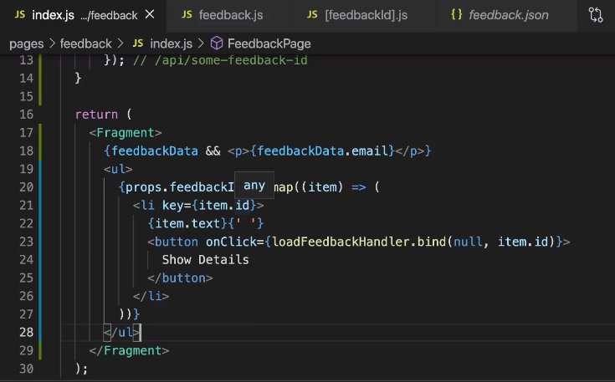

On click of “Show Details” button, api request is made and the email is displayed on the screen.

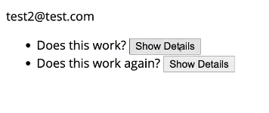

Other ways of folder structure

1st image: instead of creating “feedback.js” file, we can create “feedback” folder and create index.js file.

2nd image: [feedbackId].js is moved inside api/feedback folder. Now request to particular id should be made as “api/feedback/some-id”. This is better way of organizing

3rd image: spread operator can be used. “api/something/something” can be used now.

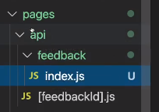 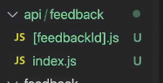 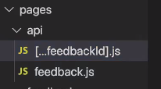

Context in next.js

1. A “store” folder is created and “notification-context.js” is created inside it. “NotificationContextProvider” helper method is created so that we can use it directly in _app.js
2. In “app.js” file, everything is wrapped inside “NotificationContextProvider” helper method.

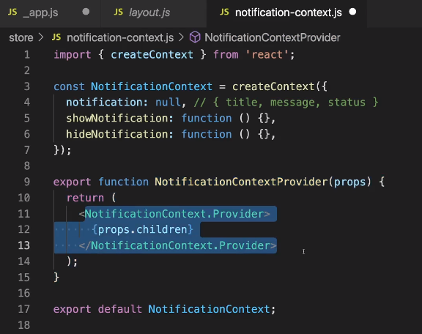 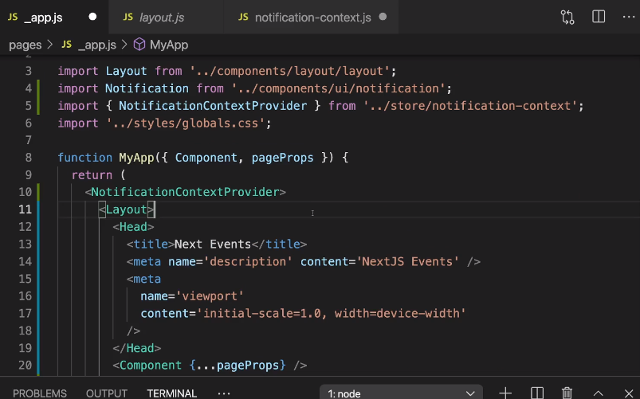

Deploying next.js app

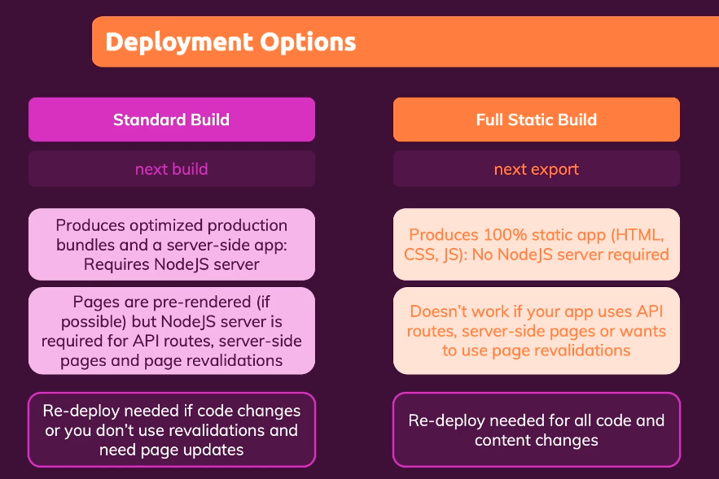 There are 2 types of deployments.

1. Standard Buil

a. Command used “next build” (as npm command)

b. Needs node js environment to run this code

c. Should be used if some dynamically rendered content is present ( getStaticProps → revalidate, fallback to true or blocking

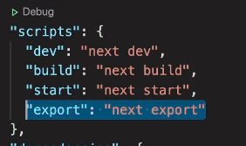2. Full Static Build

a. Command used “next export” (as npm command)

b. Needs node js environment to run this code

c. Should be used if none of dynamically rendered content is present

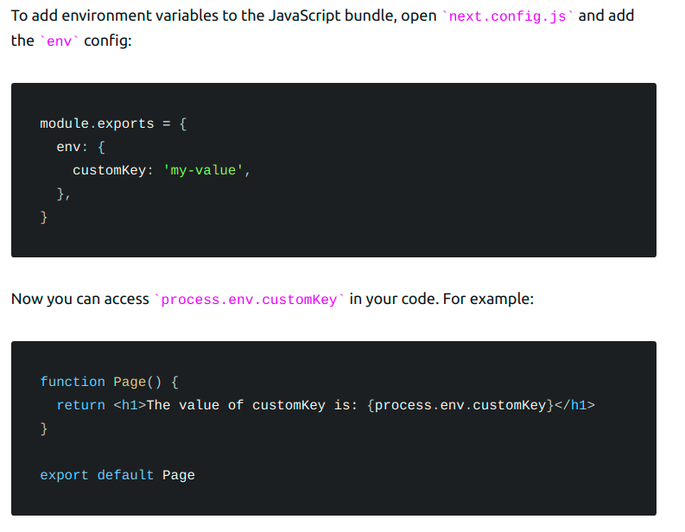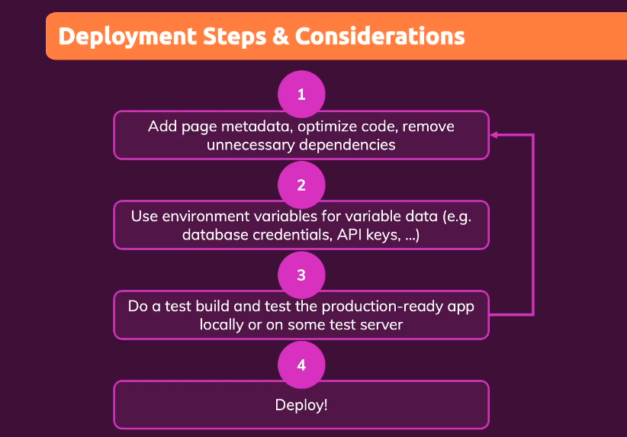

Notes while building app

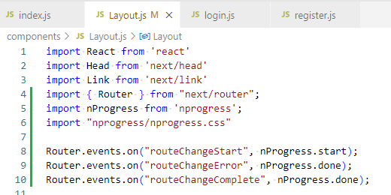 “nprogress” can be used to implement progress bar 🡪 Check this link <https://nextjs.org/docs/api-reference/next/router#routerevents> and this repo <https://github.com/vercel/next.js/blob/canary/examples/with-loading/pages/_app.js>